If any student has a problem at the Academy and they feel worried or unsafe for any reason, they can speak to any member of staff they feel comfortable talking to. If they feel worried about a Child Protection/Safeguarding issue at the Academy or something that may have happened at home, students can speak to any of the staff members below for help or advice. We also have an email address for any concerns – ‘tellsomeone@southway.org.uk’.

If any members of staff or a visitor has any concerns relating to child protection or safeguarding, they can speak to the Principal or the Designated Safeguarding Lead (DSL)
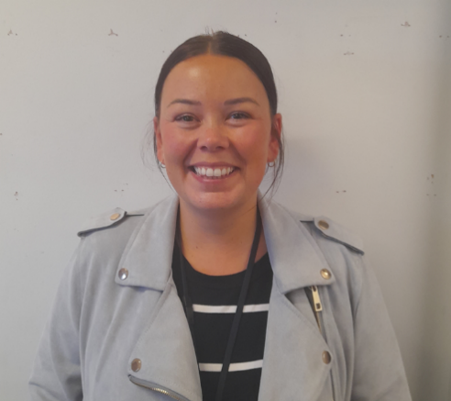
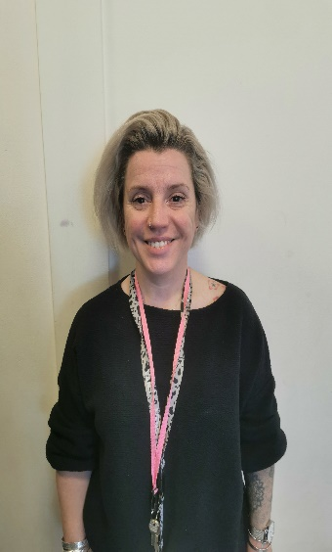
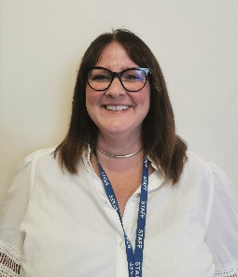


Mrs M Green
Assistant Inclusion Manager
Miss G Roberts
Deputy Head

Mrs L Waterson
Deputy Head

Mr A Collins
Vice Principal – Lead DSL

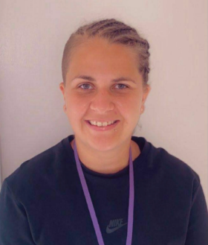
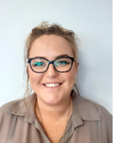
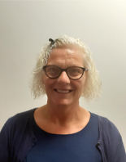
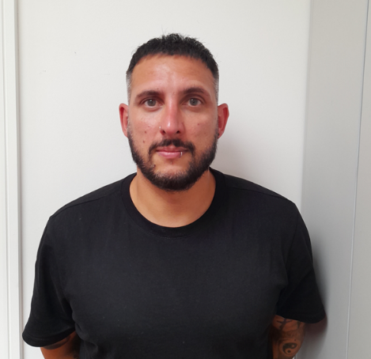

Mr M Gunjal
Head of Careers, Vocational & PSHE
Miss G Harrison
Assistant Inclusion Manager

Miss K Lockwood
Assistant Inclusion Manager

Miss D Millar
Inclusion Manager – Deputy DSL

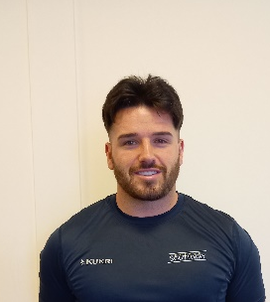
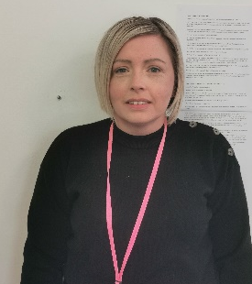
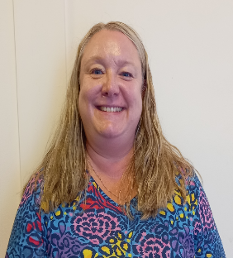
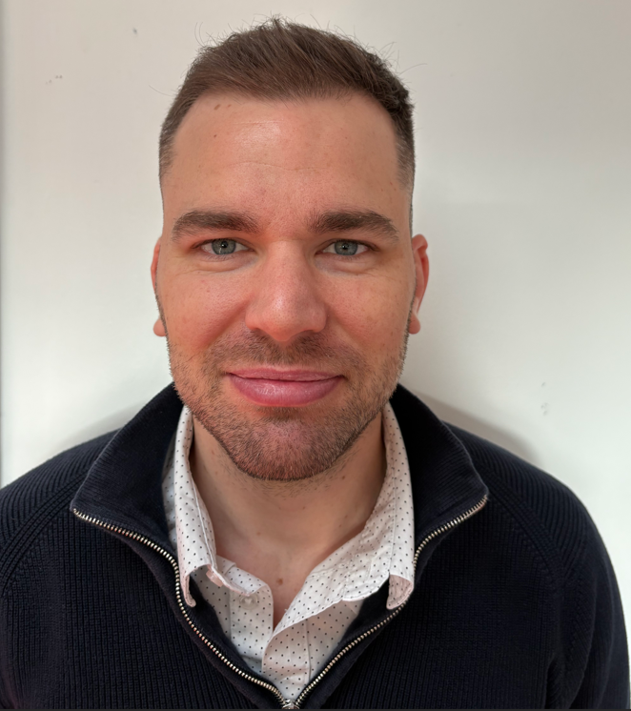
Miss C Hezlewood
AWO
Mr M Reilly
Behaviour Lead

Mrs M Callaghan
English Lead/SENDCo

Mr B Franko
Science Lead/SENDCo

Additional DSL staff;
c miller – principal
c boardman – pa/business manager
r greenwood – instructor
l moon – assistant inclusion manager
G MILLSON – ASSISTANT INCLUSION MANAGER

