Academy
Please mark the appropriate option

Rodillian Academy
BBG Academy
Featherstone Academy
Brayton Academy
UTC Leeds
Southway
Churwell Primary Academy
Holiday Notification
Exceptional Circumstance

Please mark the appropriate option

First Name of Child |  | Surname of Child |  | Date of Birth

Form Group
Address
Postcode

Full Name of  Parent/Carer (1) |  | Date of Birth of Parent/Carer (1)
Address if different from Child
Contact Number
Full Name of  Parent/Carer (2) |  | Date of Birth of Parent/Carer (2)
Address if different from Child
Contact Number

PLEASE CONTINUE TO PAGE 2
Absence Date From |  |  | Date Back at School
Please give an explanation for taking your child out of school in term time.
Would the student miss any national tests?  (Please Circle) |  | Yes |  |  | No

Parent/Carer’s Signature |  |  | Date
Request Received Date (Internal Use Only)

Please note that absence will not be authorised except in exceptional circumstances.

The Resilience Multi Academy Trust shares the government’s determination to increase student attendance at school. We want to give all our student’s the best start in life, and we know that education and support from school can help to do this.
As part of our efforts to support families, we have structured our term times to support families to book holidays at non-peak times and prices. This includes a half term in June instead of the traditional May holiday week, alongside returning to school at the end of August, rather than September *. This provides an additional week in the October half term *. Please check your child’s planner or the website for exact dates.
*Excluding UTC Leeds and Churwell Primary Academy

PLEASE CONTINUE TO PAGE 3

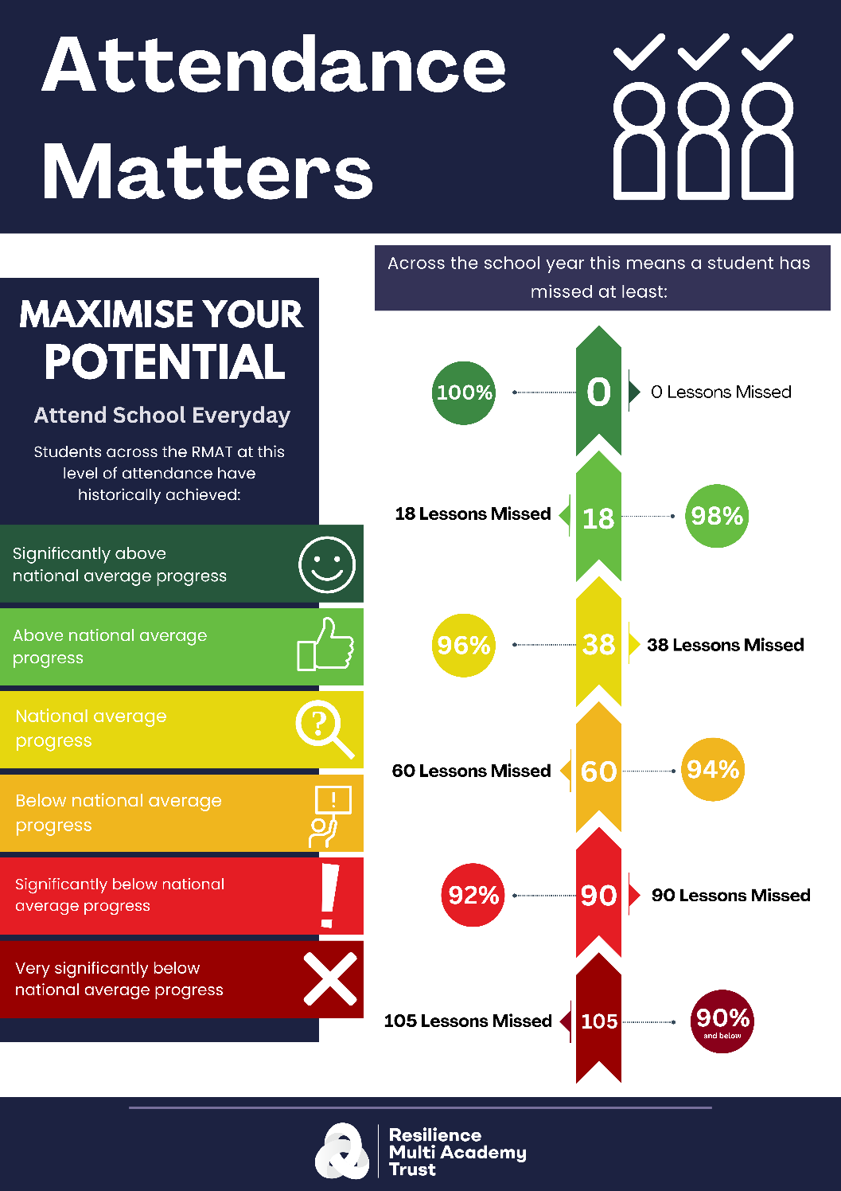

PLEASE CONTINUE TO PAGE 4

Under the new National Framework for Penalty Notice (which is Government led, not the Academy or Trust) please be aware of the following adjustments:

- Per Parent/Per Child: Penalty Notice Fines will continue to be issued per parent per child. For example, if three siblings are absent for term time leave, each parent will receive three separate fines.
- Reasons for Issuing Penalty Notices: Penalty Notice Fines will be issued for term time leave of 5 or more consecutive days, as well as for 10 sessions of unauthorised absence in a 10-week period.
- First Offence: The first time a Penalty Notice is issued for a term time holiday or irregular school attendance, the fine will be charged at £160 per parent, per child if paid within 28 days of issue, reducing to £80 if paid within 21 days.
- Second Offence: If a second Penalty Notice is issued to the same parent for the same pupil within 3 years of the first notice, the fine will be £160 per parent, per child if paid within 28 days (no reduced fee for paying early).
- Third Offence: On the third occasion of an offence within 3 years, a Penalty Notice will not be issued. Instead, the case may proceed straight to parental prosecution under the Single Justice Procedure. If found guilty, the Magistrates can impose a fine of up to £1000.

